Physics-informed neural networks predict changes in terrestrial water storage and sea levels better than climate models
Mostafa Kiani Shahvandi, Blaž Gasparini, Aiko Voigt
Department of Meteorology and Geophysics, University of Vienna
Corresponding author: mostafak57@univie.ac.at
Keywords: physics-informed neural networks; terrestrial water storage; sea level change; climate models

1 Introduction and objectives
Terrestrial Water Storage (TWS) represents all forms of water on land, including the cryosphere (polar ice sheets and mountain glaciers), the biosphere (canopies), soil and subsurface water (groundwater), and other inland water bodies (reservoirs, rivers, lakes, and wetlands). Modelling TWS remains a challenge because of difficulties in representing the water cycle on land. Furthermore, TWS is the source of mass-driven sea level change, an increasingly important contributor to sea level variation across the globe in the 20th and 21st centuries, with significant implications for coastal areas.

2 Methods and data
We leverage the potential of machine learning and propose a Physics-Informed Neural Networks (PINNs) framework for modeling and predicting TWS and its associated sea level impacts. Because TWS varies in space and time, we build our framework based on convLSTM, an architecture that is suitable for serially-correlated “two-dimensional images” of data. The physical constraint for our PINNs is provided by the physics of continental-ocean mass redistribution, i.e., the sea level component, as described by the gravitationally self-consistent methodology of the sea level equation. The sea level equation connects TWS and sea level change by considering the gravitational, rotational, and deformational feedbacks caused by TWS components, particularly the cryosphere. The method is summarized in Figure 1.

3 Preliminary results and/or expected outcomes
We train and test our PINNs based on global TWS data (Frederikse et al., 2020) from 1900 up to the end of 2018 (1900-2001 for training; 2002-2018 for testing). The data have a temporal resolution of 1 year and a spatial resolution of ${0.5}^{∘}×{0.5}^{∘}$, and were derived from an assimilation of models and satellite gravimetry observations (in the period 2002-2018). We perform various tests and discuss the advantages and shortcomings of our PINNs framework for modeling and predicting TWS. First, we show that TWS and sea level rise can be predicted reasonably well up to 10 years ahead (relative error of less than 30% on a global scale). This might prove useful for studies of sea level rise in coastal areas. Second, we compare our predictions with those of the Ice Sheet Model Intercomparison Project (ISMIP) in CMIP6 climate models, and satellite observations of Gravity Recovery and Climate Experiment (GRACE; in the range 2015-2024). We demonstrate that our predictions are closer to GRACE observations and, therefore, more accurate (up to 40% for the lead horizon of 10 years) compared to ISMIP projections under high and low emission pathways. Finally, we discuss how the predictions could be further improved by using probabilistic deep learning approaches, particularly so-called deep ensembles. Our results show that once trained, PINNs can provide predictions orders of magnitude faster than climate models and with better accuracy.
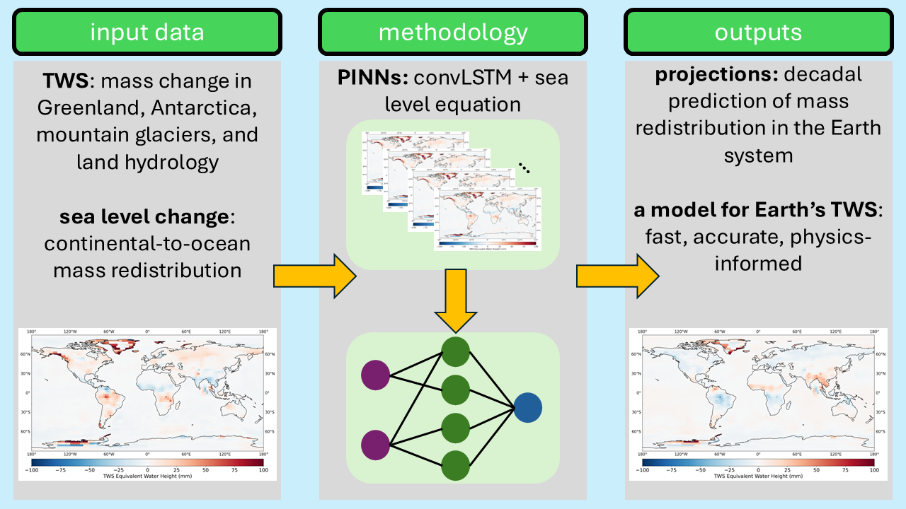Figure 1. Schematic summarizing the research. The input data include maps of TWS and sea level change since 1900. These maps are inserted into the PINNs framework, in which convLSTM is used to model the spatiotemporal nature of the data, and is furthermore augmented with sea level equation as the physics of continental-ocean mass redistribution. Using this approach, a machine learning-based model of Earth’s TWS is derived, which is then used for decadal projections of mass redistribution in the Earth system.

References
Frederikse, T., Landerer, F., Caron, L., Adhikari, S., Parkes, D., Humphrey, V.W., Dangendorf, S., Hogarth, P., Zanna, L., Cheng, L., Wu Y.-H. (2020). The causes of sea-level rise since 1900. Nature, 584, 393-397.

